**Unit 5: Functions**

**Lesson 5: Step Functions+ Peicewise functions**

**Objectives:**

* I can graph step functions
* I can identify the different features in a step function graph
* I can write a piecewise function for a real life application.

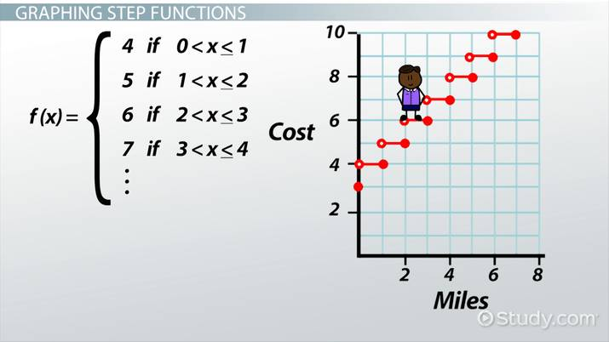**Agenda:**

* Warm up {Critical thinking}
* Video/ notes { website}
* Practice { individually and together}
* Homework: 5-4 work sheet.

**Focus Questions:**

* How can we graph a step function?
* How do we write a function for a real life application?
* 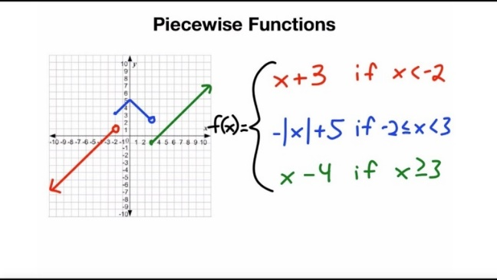How restricted domains are relate to piecewise function?

Homework 5-5

**Vocabulary:** Definitions

Step Function, Piecewise functions

**Warm up**

1. Let *f* be a function such that *f*(*x*)= 3*x* − 2 is defined on **the domain** 1 ≤ *x* ≤ 9. Sketch the functions first then find for the range based on the specific domain;
2. 9 ≤ *f*(*x*) ≤ 25 3. −∞ ≤ *f*(*x*) ≤ ∞
3. 1 ≤ *f*(*x*) ≤ 9 4. 1 ≤ *f*(*x*) ≤ 25
4. An electrician works at a job site at a rate of $40 per hour or any portion of an hour. In other words, he will charge you $40 as soon as he comes up to the first hour, and then $40 for the second hour……



1. Graph the amount the electrician charges, *c*, in dollars as a function of the number of hours he works.
2. How much does he charge for working 3.5 hours? Circle the point on the graph.

** Step functions:**  A function that increases or decreases abruptly from one constant value to another.

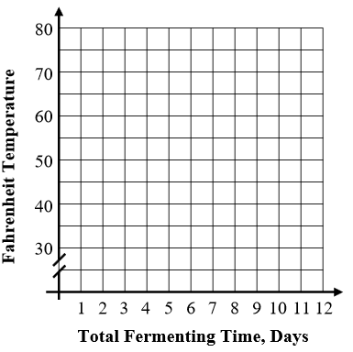**1**) When Kimchi is made, it is initially fermented for the first 3 days at a temperature of 70 degree Fahrenheit and then immediately moved to a temperature of 50 degrees Fahrenheit for another 3 days after which it is put in a 35degree refrigerator for 6 days. The Fahrenheit temperature, F, of the kimchi can be modeled over time, t, in days with the question below. Graph the Kimchi’s temperature on the grid provided.

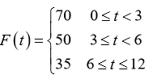

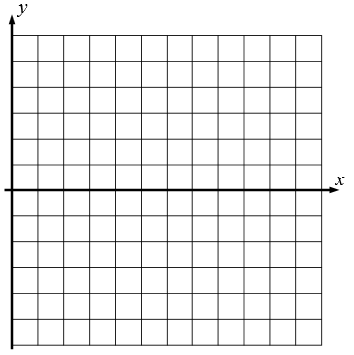

2.A. Graph the following step function

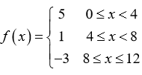

b. State the Domain and range of this function.

Evaluate f(3) ;

 **Piecewise function** is defined by more than one condition for specific intervals in its domain. Absolute value functions are specific piecewise functions

[**https://www.youtube.com/watch?v=qLzwPWEpmMg**](https://www.youtube.com/watch?v=qLzwPWEpmMg)

1. Consider the following relationship given by the function.

[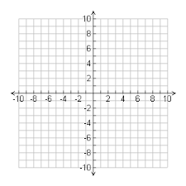](https://www.google.com/imgres?imgurl=https://mathbits.com/MathBits/StudentResources/GraphPaper/10x10.gif&imgrefurl=https://mathbits.com/MathBits/StudentResources/GraphPaper/GraphPaper.htm&docid=i5FMUDB7MITGPM&tbnid=bT37__LhgXnkWM:&vet=10ahUKEwjZod3AsfzeAhWPrVkKHdBhAuIQMwiMASgaMBo..i&w=300&h=300&bih=651&biw=1366&q=graphing%20paper&ved=0ahUKEwjZod3AsfzeAhWPrVkKHdBhAuIQMwiMASgaMBo&iact=mrc&uact=8)

1. [](https://www.google.com/imgres?imgurl=https://mathbits.com/MathBits/StudentResources/GraphPaper/10x10.gif&imgrefurl=https://mathbits.com/MathBits/StudentResources/GraphPaper/GraphPaper.htm&docid=i5FMUDB7MITGPM&tbnid=bT37__LhgXnkWM:&vet=10ahUKEwjZod3AsfzeAhWPrVkKHdBhAuIQMwiMASgaMBo..i&w=300&h=300&bih=651&biw=1366&q=graphing%20paper&ved=0ahUKEwjZod3AsfzeAhWPrVkKHdBhAuIQMwiMASgaMBo&iact=mrc&uact=8)Your turn:

$$f\left(x\right)=\left\{\begin{aligned}3-2x If -1≤ x≤1 \\ 2x-1 If x>2\end{aligned}\right.$$

**Practice: Together:**

1.The equation to determine the weekly earnings of an employee at The Hamburger Shack is given by *w*(*x*), where *x* is the number of hours worked.



1. Determine the difference in salary, *in dollars*, for an employee who works 52 hours versus one who works 38 hours.
2. Determine the number of hours an employee must work in order to earn $445. Explain how you arrived at this answer.

[](https://www.google.com/imgres?imgurl=https://mathbits.com/MathBits/StudentResources/GraphPaper/10x10.gif&imgrefurl=https://mathbits.com/MathBits/StudentResources/GraphPaper/GraphPaper.htm&docid=i5FMUDB7MITGPM&tbnid=bT37__LhgXnkWM:&vet=10ahUKEwjZod3AsfzeAhWPrVkKHdBhAuIQMwiMASgaMBo..i&w=300&h=300&bih=651&biw=1366&q=graphing%20paper&ved=0ahUKEwjZod3AsfzeAhWPrVkKHdBhAuIQMwiMASgaMBo&iact=mrc&uact=8)2) Graph the function: must provide two separate tables.

$$f\left(x\right)=\left\{\begin{aligned}2x+4 -4≤x≤2 \\ -6-x x<3\end{aligned}\right.$$

**Critical thinking:**

Is it possible to graph an absolute value function as piecewise functions? If so, explain the process or show an example.

Name: _______________ Date: ___________

5-5: Step and piecewise functions.

1)Let f be a function such that f(x)= y = 3x − 2 is defined on the domain -2 ≤ x ≤ 4. The range of this function is

-8≤ f(x) ≤ 10 −∞ ≤ f(x) ≤ ∞ -2≤ f(x) ≤ 4 4 ≤ f(x) ≤ -8

2)

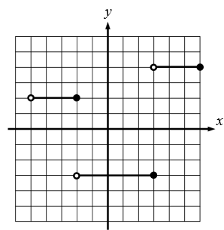

1. Write a step function for this graph.

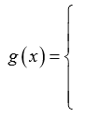

1. A store charges $15 per t-shirt for orders of 50 or fewer T-shirts, $13.50 per t-shirt for orders of 75 or fewer but more than 50 t-shirts, and $12.50 per t-shirt for orders of more than 75 t-shirts. Write and graph a function where *C* is the cost of the t-shirts, and *t* is the number of t-shirt.